FIRHAT NAWFAN HILMANDA
Financial Management
Faculty of Economics and Business - Universitas Indonesia
Graduation Batch of 2015
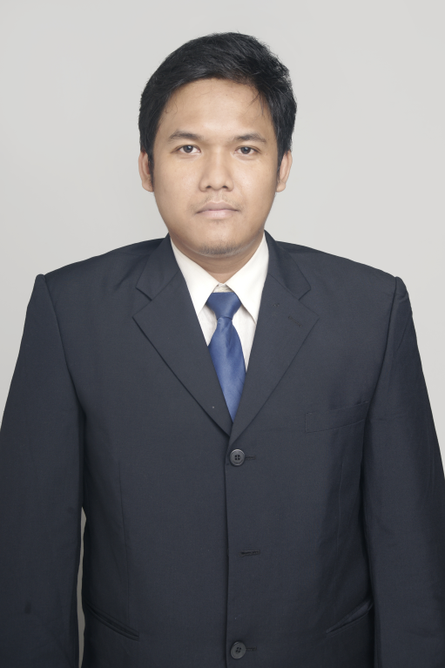
Email : firhat.nawfan.h@gmail.com
Phone : 087809089764
Birth : Malang, 03 November 1989
Nationality : Indonesian
Github : https://github.com/firhatnawfanh

GPA: 3.07
Undergraduate Thesis:
Financial Contagion between Several Financial Sector Indices of Stock Prices in This Decade
https://github.com/firhatnawfanh/bachelorthesis

Profile:
I am Bachelor of Faculty of Economics and Business – Universitas Indonesia majoring in Financial Management, recently graduated in August 2015, pursuing career in the field in Finance with a healthy interest in Information Technology and Data Science
During the course of my study, I had taken the mandatory classes of Financial Statement Analysis, Capital Budgeting & Project Finance, Business Simulation, Security Analysis, Portfolio Management, and International Finance. I also had taken the electives classes of Treasury Management, Banking Management, Sharia Financial Management, Human Resource Training and Development, and Management of Technology and Innovation.
Training
Intro to Computational finance and financial Econometrics with R | Datacamp | 2015
Introduction to Statistics with R | Datacamp | 2015
Kaggle R Tutorial on Machine Learning | Datacamp | 2015
Financial Engineering and Risk Management Part 1 | Coursera | 2016
R Programming, Exploratory Data Analysis, Getting and Cleaning Data, Reproducible Research | Coursera | 2015  2016

Other Training and Certification
Comprehensive Test of English (CTE), English Self-Access Centre, Faculty of Economics, Universitas Indonesia, scored 617 from maximum score of 667 | 2015
Pelatihan Penulisan Artikel Jurnal Ilmiah Bidang Sosial Ekonomi | 2014

Skills
Fluent in English, both written and spoken
Financial Modelling and Data Analysis using Excel, VBA, and R
https://github.com/firhatnawfanh/Finance
Statistical SPSS, STATA, EVIEWS
Organizational Experience

Pusat Bimbingan Karir dan Magang (PBKM)
Centre of Career and Internship Guidance
Faculty of Economics and Business – Universitas Indonesia
(2008-2011)

Project Development Staff | 2009-2010
As a member of project development department, I was tasked to design organization activities and annual project
General Administration Manager | 2010-2011
My duty was mainly to deal with day to day administration of the organization, including organizing database and issuing document. However since we work in a matrix structure, I was also involved on different part of the organization, including discussing and formulating the concepts and structure of the events organized within the current period


ShARE is a student organization which focused on research and sharing and as a platform to share knowledge. ShARE is also both think thank and educational hub, the insights gained from knowledge creation at ShARE can be shared not only amongst the ShARE community, but can also offer corporate and social leaders a novel perspective in tackling pertinent economic and business issues. http://share-share.org/
(2009-2011)

Network Manager of Financial Studies | 2010-2011
As a Network Manager of Finance Network, I am responsible for the training of junior member to research on financial issues, and to guide them on their research. In my term as network manager, we work on the the issue of the formation of OJK (Indonesian Financial Service Authority) and the issues of Entrepreneurship in Depok
https://github.com/firhatnawfanh/IHP

Social Work

Volunteer Teacher | Rumah Belajar "Ikhlas Bercahaya" BEM UI | 2010
Rumah Belajar is program of BEM (student body) - Universitas Indonesia which is aimed to give cram school for children of lower income family around and to provide for to those who had taken “Kejar-Paket” education a mentor for their “Kejar-Paket” test. I was a teacher for student on first year of high school, while also teaching other classes that was short on teacher
Coordinator of Teaching Material | MASTER "Masjid Terminal" | 2010
MASTER is a program of Department Pengabdian Masyarakat (Department of Social Service) of BEM Faculty of Economics – Universitas Indonesia which provide education to high school aged teenager from lower income family in collaboration with local NGO, which is Yayasan Bimbingan Insan Mandiri (YABIM) which is located near the Depok’s bus terminal.
My duty was to made syllabus, teaching material, problem sets and the answer of the problem sets, however due to lack of teacher, I also perform teaching duty. The problem with the teaching activity was that the quality of the student was horrible, for example sizeable part of them who were in the last year of high school, had the mathematical capabilities of junior high school, some even worse, incapable to differentiate between multiplication and power. The solution was to give appropriate problem of the last year high school difficulty, then analyzing the problem. Therefore any difficulties encountered during problem set would be identified, and student left behind would be given a more thorough explanation.
We also accompany select student chosen as recipient of coverage for the fee for university entrance test for select top rank student, on the site of the test as a moral support. As a result, this program has succeeded to deliver some of its student to enter Universitas Indonesia, a prestigious state university which for the child of lower income family perceived as impossible to reach.

Committee Experience
Creative Event Staff | Success 2009: “3 Dimension of Worklife : Employee , Investment, Entrepreneurship” | 2009
My duty was to look for potential speaker for the event , and schedule MoU with the the “would be” speaker. The speaker for the event was from Bahana Securities, JobStreet Indonesia, and PT Sido Muncul
Coordinator of Equipment and Permit | Success 2010: ”Renew Your Mindset to the Working Reality” | 2010
I was coordinator for procurement of equipment and coordinating permit for usage of campus facility both for the event itself and the publication, we were also responsible for disseminating publication for the event. I was given the award as best coordinator in this event
Competition Staff | 7th Economix “Asian Youth Empowerment: Challenging Asia to become The World Trade Leader” | 2009
My duty here was mainly to contact the would be jury and to some extent look for potential sponsor
Mentoring Staff | OPK 2009, organized by BPM FE UI | 2009
Event Staff | Pemilu FE UI, organized by BPM FE UI | 2009

Seminar
Participant | Senior Lecturing "Ekonomi Moneter" with lecturer : Prof Ali Wardhana, Ph.D | 2009
Participant | General Lecture on Risk Management Business Continuity Management - PT Asuransi MSIG Indonesia | 2009
Participant | Public Lecture : The US Economy and Policy Choice facing President Obama and The Congress by Paul A. London ( Former Vice Ministry of Trade USA) | 2011

Working Experience
Freelance movie translator | ~IDR 150k/ Movie or Episode

Regards

Firhat Nawfan Hilmanda

